CONTENTS

Sl No | List of Experiments
1. | Study of theodolite in detail - practice for measurement of horizontal and vertical angles.
2. | Measurement of horizontal angles by method of repetition and  reiteration.
3. | Trigonometric Leveling - Heights and distance problem (Two  Exercises)
4. | Heights and distance using Principles of tacheometric surveying (Two  Exercises)
5. | Curve setting – different methods. (Two Exercises)
6. | Determine of area using total station.
7. | Traversing using total station.
8. | Contouring using total station.
9. | Determination of remote height using total station.
10. | Stake out using total station.
11. | Distance , gradient ,diff, height between two inaccessible points using  total station.

Experiment No.: 1

STUDY OF THEODOLITE

OBJECTIVE:
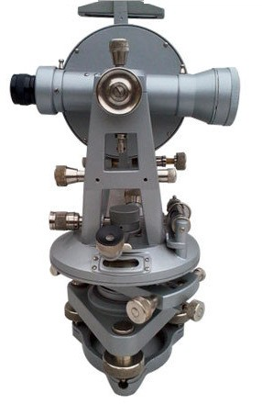
To study different parts of transit Theodolite and Temporary adjustments.

DEFINITON AND TERMS VERTICAL AXIS:
It is the axis about which the telescope can be rotated in a horizontal plane.
HORIZONTAL AXIS:
It is the axis about which the telescope can be rotated in a vertical plane.

LINE OF COLLINATION:
It is the imaginary line joining the intersection of the cross hairs of the diaphragm to the optical center of the object glass and its continuation.
AXIS OF THE TELESCOPE:
It is the line joining the optical center of the object glass to the center of the eye-piece.
AXIS OF THE LEVEL TUBE:
It is the straight line tangential to the longitudinal curve of the level tube at the center of the tube.
Department of Civil Engineering, B.V. Raju Institute of Technology (BVRIT)
CENTERING:
The process of setting the theodolite exactly over the station mark is known as centering.
TRANSITING:
It is the process of turning the telescope in vertical plane through 180º about the trunnion axis.
DESCRIPTION OF EQUIPMENT:
TELESCOPE:
It consists of eye-piece, object glass and focusing screw and it is used to sight the object.
VERTICAL CIRCLE:
It is used to measure vertical angles.
LEVELLING HEAD:
It consists of two parallel triangular plates called tribrach plates. Its uses are
- To support the main part of the instrument.
- To attach the theodolite to the tripod.

LOWER PLATE:
It consists of lower clamp screw and tangent screw.
UPPER PLATE:
The upper plate is attached to the inner axis and it carries two verniers. It consists an upper clamp screw and tangent screws. These screws are used to fix upper plate with lower plate accurately.
FOOT SCREWS:
These are used to level the instrument

PLUMB BOB:
It is used to center theodolite exactly over the ground station mark.

SWINGING THE TELESCOPE:
It means turning the telescope about its vertical axis in the horizontal plane. A swing is called right or left according as the telescope is rotated clockwise or counter clockwise.

FACE LEFT:
If face of the vertical circle is to the left side of the observer, then the observation of the angles taken is known as face left observation.

FACE RIGHT:
If the face of the vertical circle is to the right side of the observation, then the observation of the angles taken is known as face right observation.

CHANGING FACE:

It is an operation of bringing the face of the telescope from left to right and vice-versa.
Temporary Adjustment:
There are three temporary adjustments of a theodolite. These are
- Setting up the theodolite over a station.
- Leveling up.
- Elimination of parallax.
SETTING UP:
It includes two operations
- Centering a theodolite over a station: Done by means of plumb bob.
- Approximately leveling it by tripod legs only: Done by moving tripod legs radially or circumferentially.
LEVELING UP:
Having centered and approximately leveled the instrument, accurate leveling is done with the help of foot screws with reference to the plate levels, so that the vertical axis shall be truly vertical.
To level the instrument the following operations have to be done.
- Turn the upper plate until the longitudinal axis of the plate level is roughly parallel to a line joining any two of the leveling screws (A & B).
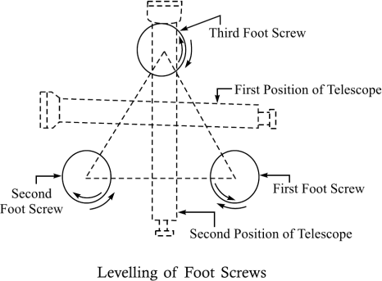

- Hold these two leveling screws between the thumb and first finger of each hand uniformly so that the thumb moves either towards each other or away from each other until the bubble comes to the center.
- Turn the upper plate through 90º i.e until the axes of the level passes over the position of the third leveling screw ‘C’.
- Turn this leveling screw until the bubble comes to the center.
Department of Civil Engineering, B.V. Raju Institute of Technology (BVRIT)

- Rotate the upper plate through 90º to its original position fig(a) and repeat step(2) till the bubble comes to the center.
Department of Civil Engineering, B.V. Raju Institute of Technology (BVRIT)
- Turn back again through 90º and repeat step 4.
- Repeat the steps 2 and 4 till the bubble is central in both the positions.
- Now rotate the instrument through 180º. The bubble should be remaining in the center of its run, provided it is in correct adjustment. The vertical axis will then be truly vertical.
- ELIMINATION OF PARALLAX:
Parallax is a condition arising when the image formed by the objective is not in the plane of the cross hairs. Unless parallax is eliminated, accurate sighting is not possible. Parallax can be eliminated in two steps.
  - FOCUSSING THE EYE-PIECE:
Point the telescope to the sky or hold a piece of white paper in front of the telescope. Move the eyepiece in and out until a distant and sharp black image of the cross-hairs is seen.
  - FOCUSSING THE OBJECT:
Telescope is now turned towards object to be sighted and the focusing screw is turned until image appears clear and sharp.

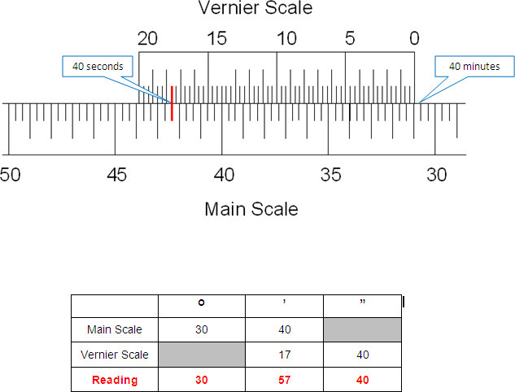

Experiment No.: 2

MEASUREMENT OF HORIZONTAL ANGLE BY REPETITION METHOD

OBJECTIVE:
To measure a horizontal angle by repetition method.

THEORY:
In this method, the angle is added several times mechanically and the value of the angle obtained by dividing the accumulated reading by the number of repetitions.

EQUIPMENTS USED:
    - Transit Theodolite
    - Tripod and
    - Ranging rods

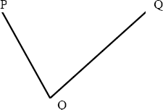

PROCEDURE:
- Set up the instrument over ‘O’ and level it accurately.
- With the help of upper clamp and tangent screw, set 0º reading on vernier ‘A’. Note the reading of vernier ‘B’.
- Release the upper clamp and direct the telescope approximately towards the point ‘P’. Tighten the lower clamp and bisect point ‘P’ accurately by lower tangent screw.
- Release the upper clamp and turn the instrument clock-wise towards Q. Clamp the upper clamp and bisect ‘Q’ accurately with the upper tangent screw. Note the readings of verniers ‘A’ and ‘B’ to get the values of the angle POQ.
- Release the lower clamp and turn the telescope clockwise to sight P again. Bisect P by using the lower tangent screw.
- Release the upper clamp, turn the telescope clockwise and sight Q. Bisect Q by using the upper tangent screw.
Department of Civil Engineering, Govt polytechnic malkangiri)

- Repeat the process until the angle measured (required number of times is 3). The average angle with face left will be equal to final reading divided by three.
Department of Civil Engineering, B.V. Raju Institute of Technology (BVRIT)
- Change face and make three more repetitions as described above. Find the average angle with face right, by dividing the final reading by three.
- The average horizontal angle is then obtained by taking the average of the two angles with face left and face right.

Experiment No.: 3

MEASUREMENT OF HORIZONTAL ANGLE BY REITERATION METHOD

OBJECTIVE:
To measure horizontal angle by reiteration method.

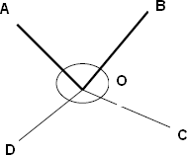

EQUIPMENTS:
  - Transit Theodolite
  - Tripod and
  - Ranging rods

PROCEDURE:
If it is required to measure angles AOB, BOC, and COD etc by reiteration method The following steps are to be used.
- Set the instrument over “O” and level it set the Vernier to zero and bisect point A accurately.

- Loose the upper clamp and turn the Telescope clockwise to point B. Bisect B by using the upper tangent screw. Read both the Verniers, the mean of the Verniers will give the angles AOB.
- Similarly, bisect successively C, D etc, thus closing the circle. Read both the Verniers at each bisection.
- Finally sight to A the reading of the vernier should be the same as the original setting reading.
Repeat the steps 02 to 04 with other face i.e. face Right.
Department of Civil Engineering,Govt polytechnic malkangiri)

Experiment No.: 4 & 5

DETERMINING AN HEIGHT OF OBJECT BY MEASURING VERTICAL ANGLE

OBJECTIVE:
Determining a height of object by measuring vertical angle.
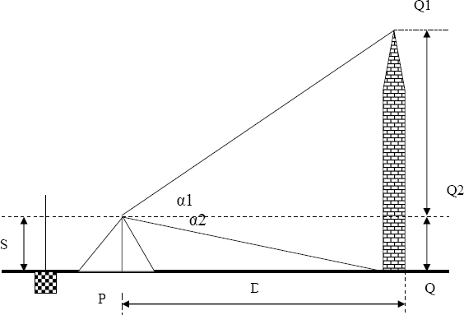
EQUIPMENTS:
- Theodolite
- Leveling Stop
- Tape or Chain
- Pegs
- Plumb bob

PROCEDURE:
- Setup the instrument at station P.
- Perform all temporary adjustments.
- Bring the line of collimation horizontal
- Enter the initial readings in the tabular form.
- Swing the telescope and take staff reading over the given B.M.
- Swing the telescope towards the object.
Department of Civil Engineering,Govt polytechnic malkangiri)
)

- Release the vertical clamp screw, sight the top of the object Q1, and clamp the vertical clamp screw.
Department of Civil Engineering,Govt polytechnic malkangiri)

- Read C and D verniers and enter the readings.
- Release the vertical clamp screw, sight the bottom of the object Q, and clamp the screw.
- Read vernier readings and enter in the tabular form.
- Measure the Horizontal distance between the instrument station and the object.
- The above procedure will be repeated with the face right observation.
- The average of the two observations by transiting the telescope taken with different faces will be vertical angle.
- Calculate the height of the top point Q1 from horizontal line (h1) and height of the bottom point Q0 from horizontal line (h2) by using formula h = d tan α

Methods:
- Measurement of Height of an object when base is accessible (on level ground)

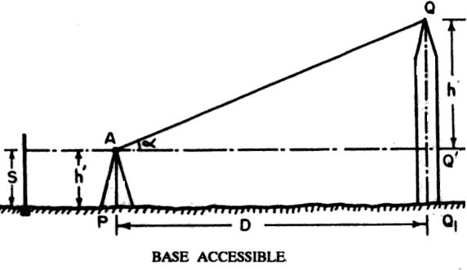
h = D tan α
Height of the object = s + h
R.L. of top of the object = R. L. of B.M. + s + h

- Measurement of Height of an object when base is inaccessible
Department of Civil Engineering,Govt polytechnic malkangiri)
)
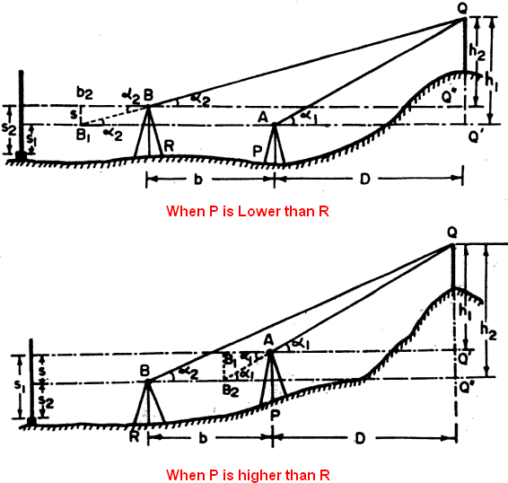
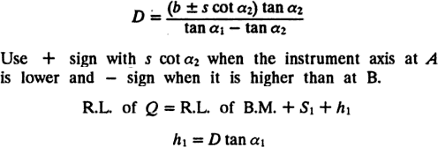

Experiment No.: 6
Department of Civil Engineering, B.V. Raju Institute of Technology (BVRIT)

DETERMINATION OF CONSTANTS OF TACHEOMETER

OBJECTIVE
To determine the multiplying constant and additive constant of the given theodolite.

EQUIPMENTS
  - Theodolite
  - Ranging Rods
  - Levelling Staff
  - Tape

PROCEDURE
- Stretch the chain in the field and drive pegs at 10m, 20m interval.
- Set the theodolite at the zero and do the temporary adjustments.
- Keep the staff on the pegs and observe the corresponding staff intercepts with horizontal site.
- Substitute the values of distance (D) and staff intercept (s) for different points in the equation D = ks + C, where k & s are the tacheometric constants. k is the multiplying constant & C is the additive constant.
- Solve the successive pairs of equations to get the value of k & C and find out the average of these values.
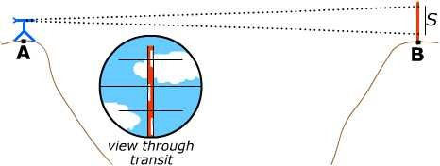

Measurement of Horizontal Distance
Department of Civil Engineering, B.V. Raju Institute of Technology (BVRIT)

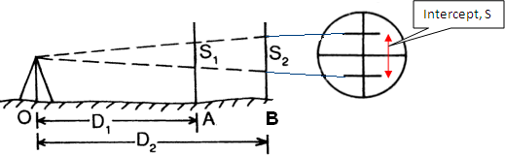

Instrument Station | Staff Station | Distance | Stadia Reading |  |  | Stadia Intercept  (S)
 |  |  | Top | Middle | Bottom
O | A
 | B

D = KS + C
D1 = K.S1 + C € 1 D2 = K.S2 + C € 2
Solve Two Equations & find K & C

RESULT: Multiplying constant, K = Additive constant, S =

Experiment No.: 7

MEASUREMENT OF HORIZONTAL DISTANCE & VERTICAL HEIGHTS USING TACHEOMETRIC SURVEYING

OBJECTIVE:
Determination of elevation of points by Tacheometric surveying

EQUIPMENT:
  - Tacheometer with tripod,
  - Tape,
  - Leveling staff,
  - Ranging rods

THEORY:
The Tacheometer is an instrument which is generally used to determine the horizontal as well as vertical distance . it can also be used to determine the elevation of various points which cannot be determine by ordinary leveling. When one of the sight is horizontal and staff held vertical then the RLs of staff station can be determined as we determine in ordinary leveling .But if the staff station is below or above the line of collimation then the elevation or depression of such point can be determined by calculating vertical distances from instrument axis to the central hair reading and taking the angle of elevation or depression made by line of sight to the instrument made by line of sight to the instrument axis.

Procedure:
- Set up the instrument in such a way that all the point should be visible from the instrument station.
- Carryout the temporary adjustment and set vernier zero reading making line of sight horizontal.
- Take the first staff reading on Benchmark and determine height of instrument.
- Then sight the telescope towards the staff station whose R.Ls are to be calculated. Measure the angle on vernier if line of sight is inclined upward or downward and also note the three crosshair readings.
- Determine the R.Ls of various points by calculating the vertical distance
Department of Civil Engineering, B.V. Raju Institute of Technology (BVRIT)

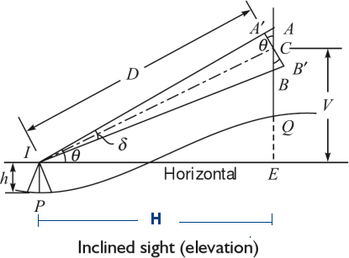
Department of Civil Engineering, B.V. Raju Institute of Technology (BVRIT)
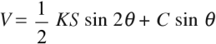

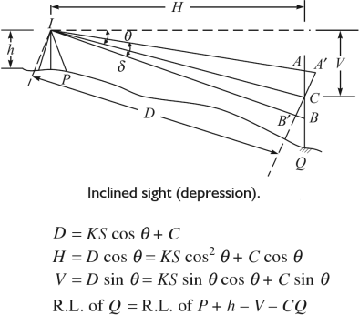

Experiment No.: 8
Department of Civil Engineering, B.V. Raju Institute of Technology (BVRIT)

SIMPLE CURVE SETTING
BY OFFSETS FROM LONG CHORD METHOD

OBJECTIVE:
To set out a simple curve by linear method (offsets from long chord method)

EQUIPMENT:
  - Cross Staff,
  - Arrows,
  - Ranging rod
  - Tape

THEORY:
Linear methods are used when:-
- High degree of accuracy is not required
- The curve is short

Linear methods for setting out curve include
- By ordinates or offsets from long chord.
- By offsets from tangents (T)
  - Perpendicular offsets
  - Radial offsets

ELEMENTS OF SIMPLE CIRCULAR CURVE
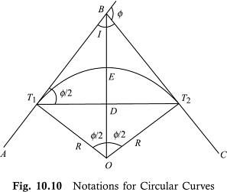

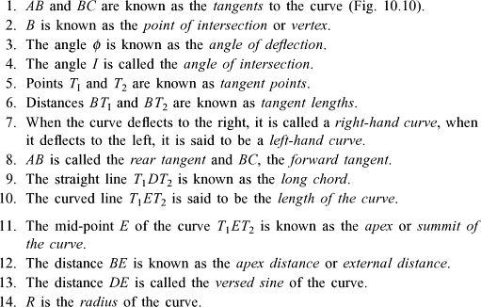
Department of Civil Engineering, B.V. Raju Institute of Technology (BVRIT)
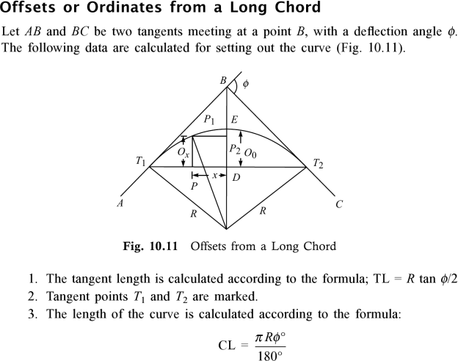

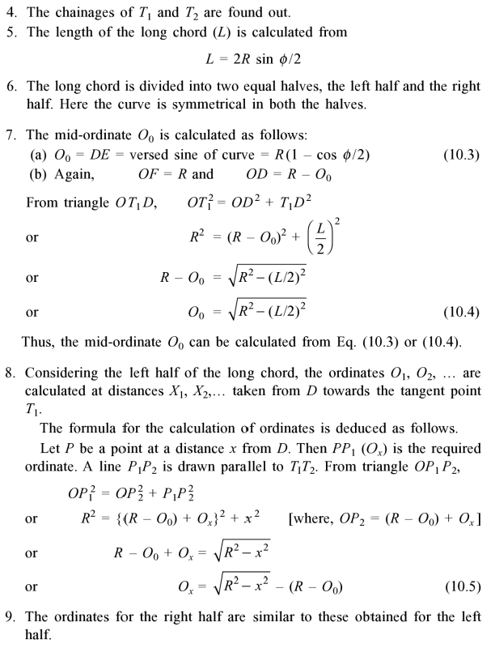
Department of Civil Engineering, B.V. Raju Institute of Technology (BVRIT)

Experiment No.: 9
Department of Civil Engineering, B.V. Raju Institute of Technology (BVRIT)

SETTING OUT OF SIMPLE CIRCULAR CURVE BY RANKINE METHOD

OBJECTIVE:
Setting out of simple circular curve by Rankine method of tangential angle.

EQUIPMENT:
- Theodolite with Tripod
- Ranging rods
- Arrows
- Tape

Horizontal Curve Setting by Ranking Method
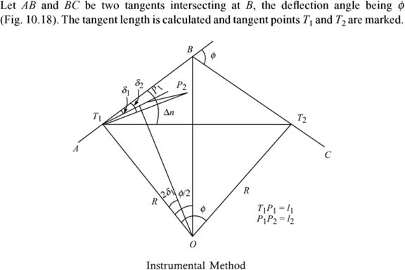

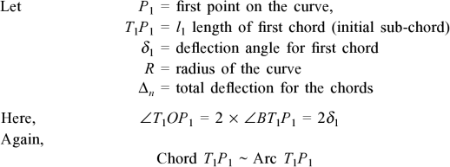
Department of Civil Engineering, B.V. Raju Institute of Technology (BVRIT)
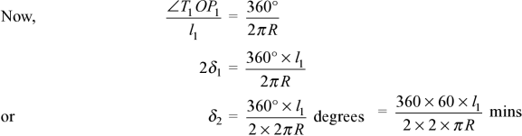

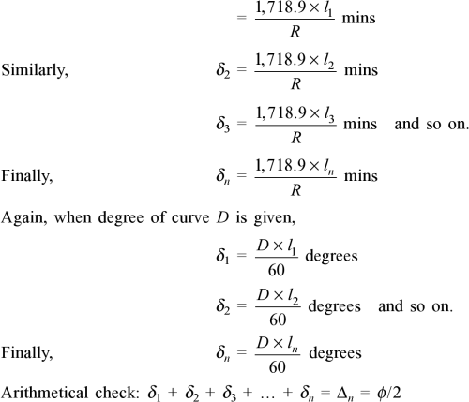

PROCEDURE:
Department of Civil Engineering, B.V. Raju Institute of Technology (BVRIT)
- Set the theodolite at the point of curve T1.
- With both the plates clamped to zero, direct the theodolite to bisect the point of intersection V. The line of sight is thus in the direction of the rear tangent.
- Release the vernier plate and set angle 1 on the vernier .The line of sight is thus directed along chord T1A.
- With zero end of tape pointed at T1 and arrow held at a distance T1A = c along it, swing the tape around T1 till the arrow is bisected by the cross hairs.
- Thus the first point A is fixed.
- Set the second deflection angle 2 on the vernier so that the line of sight is directed along T1B.
- With the zero end of the tape pinned at A, and an arrow held at distance AB = C along it, swing the tape around A till the arrow is bisected by the cross hairs, thus fixing the point B.
- Repeat steps 4 and 5 till last point is reached.

L E V E L L I N G

Study of dumpy level and leveling staff

  - Temporary adjustments of dumpy level.

  - Taking out levels of various points and booking in a level field book.

  - Differential or fly leveling-reduced levels by H-I method rise and fall method.
  - Differential leveling involving invert levels-reduction by H-I method, rise, and fall methods.

STUDY OF DUMPY LEVEL AND LEVELLING STAFF

OBJECTIVE
Study of components of dumpy level and leveling staff.
INSTRUMENT:
A level and leveling staff.

FIGURE:
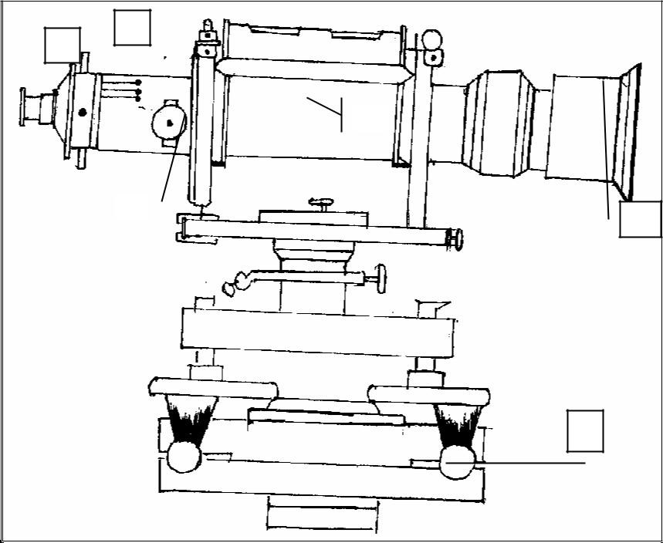
3
4
2
5
6
1

Leveling head 4. Diaphragm
    - Telescope 5. Focusing screw
    - Eye-piece 6. Ray-shade

The Major Components Of A Dumpy Level

TELESCOPE:

It contains of two metal tubes, one of which slides within the other one-tube carries the object glass and the second one carries eyepiece and diaphragm
FOCUSSING SCREW:
The telescope is focused by turning the focusing screw either forward or backward.
BUBBLE TUBES:
The telescope is attached with two bubble tubes. One is longitudinal and the other is cross bubble tube. These two are placed at right angles to each other.
DIAPHRAGM:
It carries cross hairs.
TRIBRACH & TRIVET:The telescope with vertical spindle is supported by two parallel triangular plates. The upper plate is called tribrach and the lower plate is called trivet
FOOT SCREWS:
By turning the foot screws, the tribrach can be raised or lowered to bring the bubble to the center of its run.
LEVELLING STAFF:
THE LEVELLING STAFF:
It is used for measuring the vertical distance of the points above or below the horizontal line of sight. The different staves in use are

- Sop with telescope staff 2. Folding staff 3. Solid staff 4. Target staff

SOP WITH TELESCOPE STAFF:

It is usually arranged in three telescopic lengths. The staff is 4m long when fully extended. The top length 12.5m is solid slides into the central box of length 12.5m, which again slides in the bottom box of 1.50m long. The staff is provided with brass spring catches to keep the extended length in position.

The meter numerals are marked on the left side and are pointed in red. The decimeter numerals are marked on the right side and are pointed in black.
The background is painted in white. The smallest division on this staff is 5mm. The graduations are marked erect and are seen inverted when viewed through the telescope.
FOLDING STAFF:
It is made of well-seasoned timber such as deodar, blue pine or aluminum. It is 4m long, 75mm wide, 18mm thick. It has two lengths of 2m each which are connected at the middle by a hinge so that the upper portion can be folded over the lower one.

The minimum division on the staff is 5mm.
The lengths of meter in numerals are marked on the left and painted in black. The entire background is painted in white. The graduations are inverted and hence when viewed through the telescope, they appear erect.

SOLID STAFF:
It consists only one length and is usually 3m long. It is also graduated in divisions of 5mm. This is used for precise leveling work.

TARGET STAFF:
It consists of two lengths, one sliding over the other. It is graduated from top downwards. The target is equipped with vernier, which is adjusted by the staff man. The target is to be moved along the rod until its center is bisected by the line of sight. The target is then clamped and reading is taken. Target staves are used when the sights are long, say more than 100m.
\

TEMPORARY ADJUSTMENTS OF DUMPY LEVEL
OBJECTIVE:
TO OBTAIN THE ACCURATE RESULT OF LEVELLING
INSTRUMENTS: DUMPY LEVEL

PROCEDURE:
Temporary adjust of dumpy level

SETTING UP OF THE LEVEL
- LEVELLING UP
- ELIMINATION OF PARALLOX

1.SETTING UP OF THE LEVEL

Release the clamp screw of the instrument
  - Hold the instrument in the right hand and fix it on the tripod by turning round only the lower part with the left hand.
  - Screw the instrument firmly.
  - Bring all the foot screws to the center of its run.
  - Spread the tripod legs well apart.
  - Fix any two legs firmly into the ground by pressing them with the hand.
  - Move the third leg to the right or left until the main bubble is approximately in the center.
  - Then move the third leg in or out until the bubbles of the cross- level is approximately in the center.
  - Fix the third leg firmly when the bubbles are approximately in the centers of their run.

2.LEVELLING UP
  - Place the telescope parallel to a pair of foot screws.
  - Bring the bubble to the center of its run by turning the foot screws equally either both inwards and both outwards.
  - Turn the telescope through 90º so that it lies over the third foot screw.

  - Turn this third foot screw so that the bubble corners to the center of its run.
  - Bring the telescope back to the original position without reversing the eye- piece and object glass.
  - Repeat the above operations until the bubble remains in the center of its run in both the positions.

  - Turn the telescope through 180º and check whether the bubble remains central.

3.ELIMINATION OF PARALLOX:

- Remove the lid from the object glass.Hold a sheet of white paper in front of the object glass.
- Move the eyepiece in or out until the cross hairs are distinctly visible.
- Direct the telescope towards the staff.
- Turn the focusing screw until a clear and sharp image in formed in the plane of the cross hairs.

TABULAR FORM FOR HEIGHT OF INSTRUMENT (H.I) METHOD

Readings
Remarks
Station
Back sight
Inter Sight
Height of
Instrument
Fore Sight

Reduced Level

H.I = R.L of B.M + B.S
R.L of other station points = H.I – I.S or F.S ARITHMATICAL CHECK:
Σ B.S – Σ F.S = Last R.L – First R.L

FOR RISE AND FALL METHOD

 | Readings |  |  | Rise | Fall | R.L | Remarks
Station
 | Back sight | Inter Sight | Fore Sight

ARITHMATICAL CHECK:

Σ B.S – Σ F.S = Σ Rise – Σ Fall = Last R.L. – First R.L

SURVEYOR: HELPER:

TAKING OUT LEVELS OF VARIOUS POINTS AND BOOKING IN A LEVEL FIELD BOOK
DATE: TIME:

OBJECTIVE: TAKING OUT LEVELS OF VARIOUS POINTS AND BOOKING IN A LEVEL FIELD BOOK
Instrument:
1.leveling staff 2.dumpy level

PROCEDURE:

Set the level at a convenient point.
- Perform the temporary adjustments.
- Hold the staff vertically over the Benchmark, Observe the staff reading and write in the B.S column of the field book.
- Hold the staff at other points and note the staff reading in the I.S column of the field book.
- Hold the staff on the last point and enter the staff reading in the F.S column of the field book.
- Find R.L. of all the points by both the methods.
- Apply arithmetical check.

TAKING OUT LEVELS OF VARIOUS POINTS AND BOOKING IN A LEVEL FIELD BOOK
DATE: TIME:

OBJECTIVE:

TAKING OUT LEVELS OF VARIOUS POINTS AND BOOKING IN A LEVEL FIELD BOOK

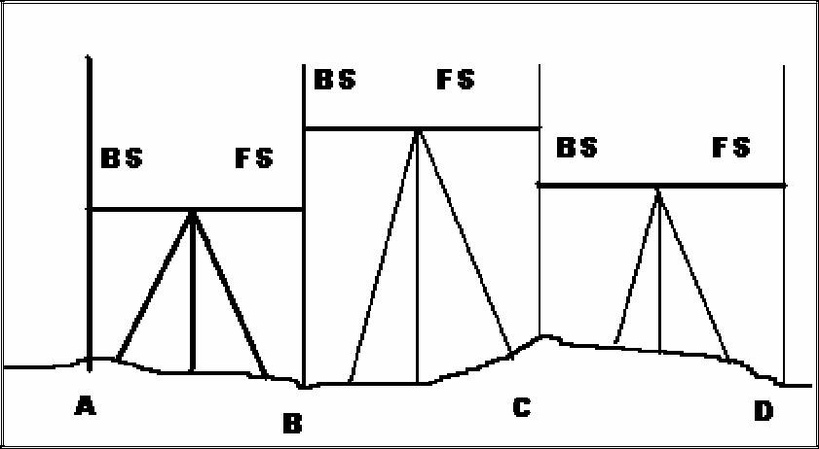

PROCEDURE:

Let A and B be the two given points whose difference is elevation is to be found.
- Set the level at a convenient point O1 carryout temporary adjustments and take B.S on A

Take FS on the Point C
- Shift the instrument to point O2 and perform temporary adjustments.
- Take B.S on C.
- Take F.S. on D.
- Shift the instrument to point O₃ and perform temporary adjustments.
- Take B.S on D
- Take F.S on B.
- Find the difference in elevation between A and B by both the methods.

Result:

Difference in elevation between A and B = ……………

Experiment No: 7
DETERMINATION OF AREA USING TOTAL STATION

  - OBJECTIVE:
To find the area of a closed traverse using total station

RESOURCES:

Sl.No. | Name of the equipment | Rage | Type | Quantity
1 | Total station |  |  | 1
2 | Prism |  |  | 1
3 | Tripod |  |  | 1
4 | Pegs

  - PERCAUTIONS

Temporary adjustment for total station
Leveling and centering
Focusing adjustment

  - PROCEDURE
- Fix the total station over a station and level it
- Press the power button to switch on the instrument.
- Select MODE B -------> S function------->file management------>create(enter a name)-------
>accept
- Then press ESC to go to the starting page
- Then set zero by double clicking on 0 set(F3)
- Then go to S function ------> measure-----> rectangular co-ordinate---->station >press enter.
- Here enter the point number or name, instrument height and prism code.

- Then press accept (Fs)
- Keep the reflecting prism on the first point and turn the total station to the prism, focus it and bisect it exactly using horizontal and vertical clamps.
- Then select MEAS and the display panel will show the point specification
- Now select edit and re-enter the point number or name point code and enter the prism height that we have set.
- Then press MEAS/SAVE (F3) so that the measurement to the first point will automatically be saved and the display panel will show the second point.
- Then turn the total station to second point and do the same procedure.
- Repeat the steps to the rest of the stations and close the traverse
- Now go to S function----> view/edit graphical view.
- It will show the graphical view of the traverse.
- Select S function---> calculation---> 2D surface----> All > accept
- This will give the area of the closed traverse.

DIAGRAM:
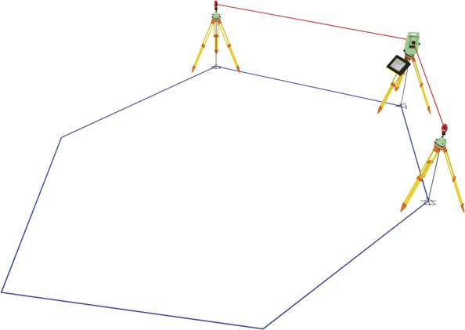

  - Calculation :
Select S function---> calculation---> 2D surface----> All > accept

RESULTS
Select S function---> calculation---> 2D surface----> All > accept
This will give the area of the. Area of the is calculated.

Experiment No: 8 TRAVERSING USING TOTAL STATION

  - OBJECTIVE:
To form a closed traverse using total station

RESOURCES:

S.No. | Name of the equipment | Rage | Type | Quantity
1 | Total station |  |  | 1
2 | Prism |  |  | 1
3 | Tripod |  |  | 1
4 | Pegs

  - PERCAUTIONS

Temporary adjustment for total station
Leveling and centering
Focusing adjustment

  - PROCEDURE
- Fix the total station over a station and level it
- Press the power button to switch on the instrument.
- Select MODE B -------> S function------->file management------>create(enter a name)-------
>accept
- Then press ESC to go to the starting page
- Then set zero by double clicking on 0 set(F3)
- Then go to S function ------> measure-----> rectangular co-ordinate---->station >press enter.
- Here enter the point number or name, instrument height and prism code.

PN .....................................................
E..........................................................
N............................................................
IH..........................................................
PC.........................................................
A
B
F
Closed traverse
C

E
D
- Then press accept (Fs)
- Keep the reflecting prism on the first point and turn the total station to the prism ,focus it and bisect it exactly using a horizontal and vertical clamps.
- Then select MEAS and the display panel will show the point specification
- Now select edit and re-enter the point number or name point code and enter the prism height that we have set.
- Then press MEAS/SAVE (F3) so that the measurement to the first point will automatically be saved and the display panel will show the second point.
- Then turn the total station to second point and do the same procedure.
- Repeat the steps to the rest of the stations and close the traverse
- Now go to S function----> view/edit graphical view.
- It will show the graphical view of the traverse.

DIAGRAM:

  - Calculation :

Select S function---> calculation---> 2D surface----> All > accept

RESULTS

Select S function---> calculation---> 2D surface----> All > accept
This will give the area of the closed traverse. Area of the closed traverse is calculated

Experiment No: 9
HEIGHTS AND DISTANCE USING PRINCIPLES OF TACHEOMETRIC
SURVEYING

  - OBJECTIVE:
To find the heights and distance using principles of Tachometric surveying

RESOURCES:

S.no | Name of the equipment | Rage | type | quantity
1 | Thedolite |  |  | 1
2 | Taps |  |  | 1
3 | Arrows |  |  | 4
4 | Ranging rods |  |  | 4
5 | Tripod |  |  | 1

  - PERCAUTIONS

Temporary adjustment for Theodolite
    - Leveling and centering
    - Focusing adjustment

  - PROCEDURE
This method is used when the Theodolite is not equipped with a stadia diaphragm. In this method, angular observations are made for two vanes at a fixed vertical distance between them usually 3 m and the horizontal and the vertical distances are computed.

CASE: 1 WHEN BOTH ANGLES ARE IN ELEVATION

Let S be the vertical distance between the vanes A and B. V the vertical distance between instrument axis and lower vane, h staff reading to lower vane: D horizontal distance of staff station from instrument, α1 and α2 vertical angles to vanes A and B respectively.

Then S+V=D tan α
D=S cosα1 cosα2 / sin (α1-α2)
V=D tan α2= S cosα1 sinα2 /sin (α1-α2) Elevation of staff station =El.of inst.axis + V- h

CASE: 2 WHEN BOTH ANGLES ARE IN DEPRESSION

When both angles are of depression:
V-S= D tan α2 V=D tan α1
S=D (tanα1-tanα2) D= S / tanα1-tanα2
V=d tan α1= S sinα1 cosα2 / sin (α1-α2)
Elevation of staff station = Height of instrument – V – h

DIAGRAM:
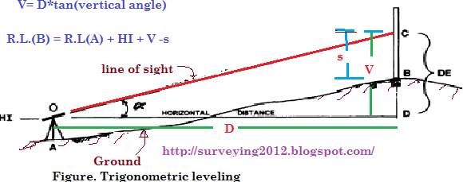

  - TABULATION:

Inst.  Station | Height of  axis | Staff Stations | Vertical  Angle | Hair readings | Remarks

RESULTS
Stadia intercept values top ----- middle ------- bottom-------

Experiment No: 12
STAKE-OUT USING TOTAL STATION

  - OBJECTIVE:
To find a specific point in the field using Total Station

RESOURCES:

S.no | Name of the equipment | Rage | Type | Quantity
1 | Total station |  |  | 1
2 | Prism |  |  | 1
3 | Tripod |  |  | 1
4 | Pegs

  - PERCAUTIONS

Temporary adjustment for total station
    - Leveling and centering
    - Focusing adjustment

  - PROCEDURE
Place the total station in the spot from which you want to stake out points after you have finished entering the coordinates for the area into the total station's internal memory.Make sure that the total station is level and on secure, even ground before continuing. Press the "Power" button to turn on the instrument.
Press the "Menu" button and use the navigation arrows to move down to the "Stake Out" menu option. Press the "Select" button to enter the stake out menu.Select the method to stake out the point. Select "XY" to stake out by coordinates which will be the most common method.

- Press the "Yes" button to continue the process using the coordinates on the screen.

- If the coordinates are incorrect, press the "No" button to try again.

- In the next screen, use the keypad to enter the coordinates or distances and press the "OK" button to measure.
- The results will be displayed on the following screen.

DIAGRAM:
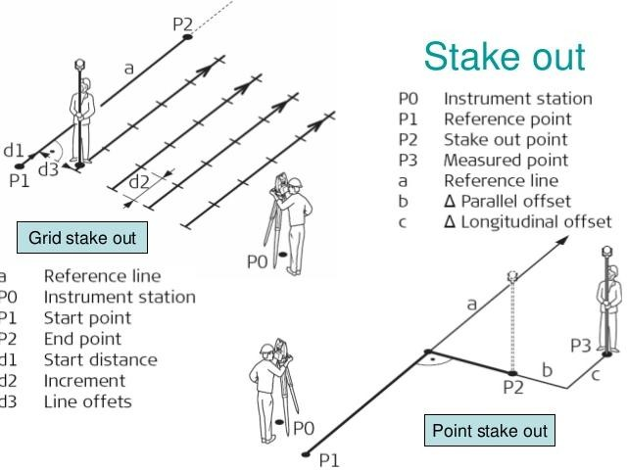

Calculation :
Select Stake function---> calculation---> 2D surface----> All > accept

RESULTS
Select Stake function---> calculation---> 2D surface----> All > accept

