Experiment 1 Measurement by Slide Calipers.
- AIM :
To find the length of a body / the radius of a wire / the internal & external diameter of a hollow cylindrical body / depth of a uniform cylinder or water column etc.
- APPARATUS :
- Slide caliper b) the given specimen
- DECRIPTION :
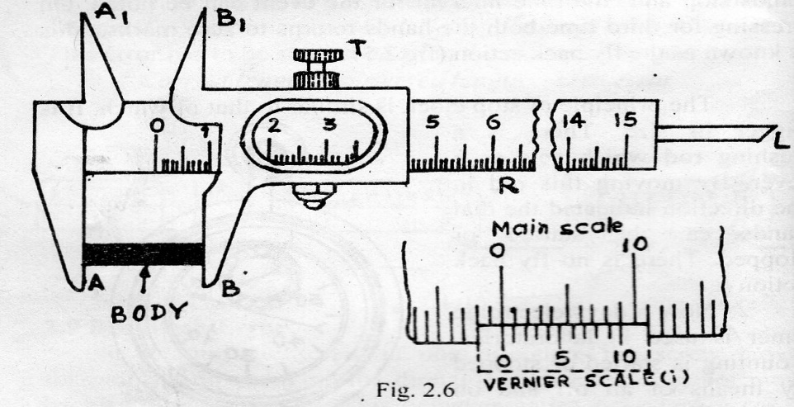
It consists of a main scale R, Which is graduated in cms on one side and in inches on other side of a nickel coated steel plate. There are two jaws AA₁ and BB₁ attached perpendicular to the scale. AA₁ is fixed at one end of the main scale where as BB₁ is movable i.e. it can be slided over the main scale. The movable jaw BB₁ carries a Vernier scale V and a fixed nut T. It slides along the main scale and can be fixed at any position with the help of fixed nut T.
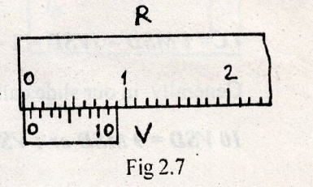
The Vernier scale is an auxiliary scale, which is used in conjunction with the main scale for measuring the fractions of the smallest division of the main scale. The graduation of the Vernier scale is not exactly same as that of main scale. In most of the slide calipers, we use in laboratory, 10 divisions of the Vernier scale coincides with 9 divisions of main scale (fig.2.7). When both jaws are in contact the zero of the main scale should coincide with zero of Vernier scale, if this is not so, then there is an error known as zero error. The upper pair of jaws A₁B₁ is used to find the internal diameter the hollow cylinder or tube. Along with the movable jaw a rod L is provided for finding the depth.
- THEORY :
Required Length = Main scale reading (MSR) + Vernier scale reading (VSR)
VSR = Vernier coincidence (VC) x least count (LC), Hence
Required Length = MSR + VC x LC
The length measurement involves the determination of
- Lest count LC and
- Reading of MSR and VC
- Least Count: To start with, we have to find the least count (LC) of slide caliper. The least count is the smallest measurement that can be made by an instrument. It is equal to difference of one main scale division and one Vernier scale division.
LC = 1 main scale division (MSD) – 1 Vernier scale division (VSD)
Suppose n division of Vernier scale = (n - 1) division of main scale.
Or n VSD = (n - 1) MSD
1 VSD = $\frac{(n-1)}{n}$ MSD
LC = 1 MSD – 1VSD = 1- $\frac{(n-1)}{n}$ = $\frac{1}{n}$ MSD
Generally, in our slide calipers
10 VSD = 9 MSD or 1 VSD = $\frac{9}{10}$ MSD
So LC = 1MSD – 1VSD = 1 $\frac{9}{10}$ = $\frac{1}{10}$ MSD
And 1 MSD = 1mm = 0.1 cm
Hence LC = $\frac{1}{10}$ x0.1 cm = 0.01 cm.
- Reading of MSR. And VC: Place the body between two jaws and move the sliding jaw till the body is held tight.
Look at the position of Vernier zero on the main scale. If it coincides with any mark of main scale, that reading gives MSR. The VC in this case is zero. So the total length is equal to MSR. This is a rare case.
Generally Vernier zero lies in between two marks of main scale. In that case. The mark left to Vernier zero is SR.
Illustration Suppose, that during certain observation, zero of the Vernier scale lies between 1.2 and 1.3 cm marks (fig. 2.8). Therefore, the length of the body under measurement is 1.2 cm plus some fraction. The MSR. Is 1.2 cm and the fraction to be added is VSR. To find VSR. We have to know Vernier coincidence (VC). The VC is found by locating which Vernier division coincide with a main scale division, which in present case is 6 (fig.2.8).
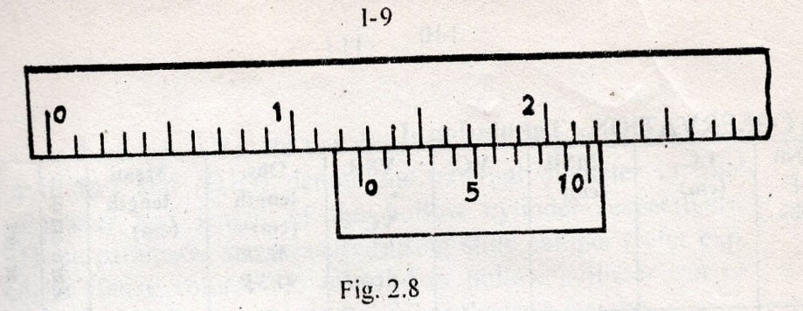
So VSR = 6 x LC = 6 x 0.01 = 0.06 cm. Hence, the length of the cylinder = MSR + VSR = 1.2 + 0.06 = 1.26 cm.
- PROCEDURE :
- Make standardization of the main scale. This can be done by comparing 10 divisions of the main scale with a standard meter scale by means of a divider, hence finding the value of 1 main scale division. Generally, in all the slide calipers one main scale division is 0.1 cm or 1 mm.
- Find least count and zero error of the given slide caliper. Keep the body in between the two jaws. Adjust the movable jaw till the body is held tight.
- Note the main scale reading MSR and Vernier coincidence VC carefully (refer theory). Calculate VSR = VC x LC.
- Repeat the similar procedure by changing the position of the body for 10 times. Find the observed length in each observation. Then find the mean observed length.
- Find the correct length by making corrections for zero error. For zero error refer section 2.5.
- Repeat the steps (iii) to (IV) for 5 to 6 times. Enter everything in a tabular form as under:
- PRECAUTIONS:
- Working of the caliper should be carefully examined. If its motion is not smooth, it should be oiled.
- The jaws should not be pressed very hard against each other.
- The upper jaws should be used for internal diameter measurement and lower jaws for external diameter measurement.
- Diameter must be measured for two mutually perpendicular directions at same place.
- OBSERVATION : Tabulation -1
No of obs. | LC  (cm) | MSR  (cm) | VC | VSR = VC x LC  (cm) | Obs length  (cm)= MSR + VSR | Mean length  (cm) | Zero error | Correct  Length (cm)
1
2
3
4
5
6
7

- CALCULATION :

- RESULT :
The required length/ radius/ diameter/ depth is found to be ….

Experiment 2. Measurement by Screw Gauge
- AIM :
To find the thickness of a thin plate / the radius of a thin wire / the diameter of a small spherical ball.
- APPARATUS:
- Screw gauge b) the given specimen
- DESCRIPTION :
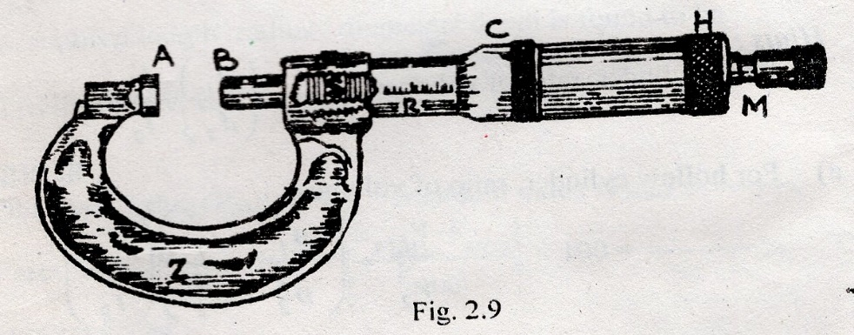
Screw Gauge consists of a U shaped steel frame Z having two arms. Left arm is provided with a fixed stud with plane surface A and right arm is provided with a cylindrical tube on which a linear scale with a reference line R is attached (fig. 2.9). An accurately cut screw S is moved co-axially inside the cylinder by rotating the cap H to which screw head is fixed. The ratched M of the cap H is milled. There is
a circular scale C having 100 or 50 equal division on the other end of the cap. The other end of the screw is provided with a stud B and moves to change the gap between A and B. even when two studs are in contact (i.e. the gap is closed) M turns without moving the screw. This helps to avoid undue pressure over the object held between the studs A and B. In contact position of the studs the zero mark of the circular scale may coincide with the reference line of the main linear scale R. Otherwise, the screw gauge is said to have an error known as zero error or instrumental error.
- THEORY:
Required thickness = Pitch scale reading (PSR) + Circular scale reading (CSR.)
PSR = Pitch x No. of complete rotation (N).
CSR = least count LC x difference between I and F i.e. (I~F).
Where I is the initial circular scale coincidence (ICSC) and F is the final circular scale coincidence (ICSC).
Hence, Thickness = (Pitch x N) + LC x (I~F)
Hence the thickness measurement involves
- Determination of pitch and least count b) reading of 1, N & F.
- Pitch and Least Count (LC):
Pitch is the perpendicular distance between two consecutive threads of the screw or distance moved by the screw in one complete rotation.
To determine the pitch, give 10 complete rotations to the circular scale and note the distance moved by the screw in liner scale. Then divide this distance by 10 which gives the value of pitch.
In most common screw gauges, the distance moved by the screw in 10 complete rotations is 5 mm or 0.5 cm. the value of pitch is 0.5/10 = 0.05 cm. In some screw gauge the value of pitch is 0.1 cm.
Least count (LC) is the smallest measurement that can be made by an instrument (screw gauge). It can be calculated by noting the distance through which the screw moves when circular cap is rotated through one division on the circular scale.
L.C = $\frac{Pitch}{Total number of divisions in circular scale}$
= $\frac{0.05}{100}$ = 0.0005 cm or $\frac{0.1}{100}$ = 0.001 cm
As the case may be.
- PROCEDURE:
- Make standardization of the linear scale as done in slide caliper.
- Find the pitch and least count of the given screw gauge (refer the theory)
- Introduce the given glass piece or wire between A and B and rotate the milled head until it is held tightly between the studs. This can be ensured with the sound of a click.
- Read the circular scale division lying exactly on the reference line. This number is called initial circular scale coincidence ICSC or simply (I).
- Remove the object or wire. The gap will be left between two plane surfaces A and B. This gap measures the thickness of the object or diameter of the object.
- Close the gap by giving rotation to the screw head and note the number of complete rotations (N) and read the circular scale division which coincides with the reference line when the gap is fully closed. This number gives the final circular scale coincidence FCSC or simply (F). The difference between I and F gives the number of extra circular scale divisions required to close the gap. It may I~F, if I>F or 100 + I ~F, if I<F.
As the thickness is measured by difference of initial and final circular scale reading, the zero error is eliminated.
It is clear from the above observation that the gap requires N number of complete rotations and (I~F) number extra divisions in order to be closed. So naturally the thickness will be
(Pitch x N) + LC x (I~F) or PSR. + CSR.
- Find out PSR. And CSR. The sum of the two gives the thickness of the glass piece.
- Repeat procedures (iii) to (vii) by changing the position of the glass piece and enter in a tabular form as under:
- PRECAUTIONS:
- The reading should be taken by moving the screw only in one direction to avoid back-lash error.
- The screw system should be properly lubricated.
- Move the screw by holding the ratchet arrangement, not its cap.
- Put the sample in two mutually perpendicular directions.
- OBSERVATION: Tabulation-II
No of obs. | Pitch  (P)  Cms. | LC  cms | ICSC  (I) | N | FCSC  (F) | (I$\sim F$) | PSR = Pitch x N  cms | CSR = (I~F) x LC  cm | Total thickness = (PSR + CSR) cm | Mean thickness cm

- CALCULATION:

- RESULT:
The required thickness/ radius/ diameter/ is found to be …

Experiment 3 Measurement by Spherometer
- AIM:
- To determine the thickness of thin plate (ii) to find the radius of curvature R of a curved surface (watch glass) using spherometer.
- APPARATUS:
- Spherometer b) plane glass plate c) supplied sample
- DESCRIPTION:
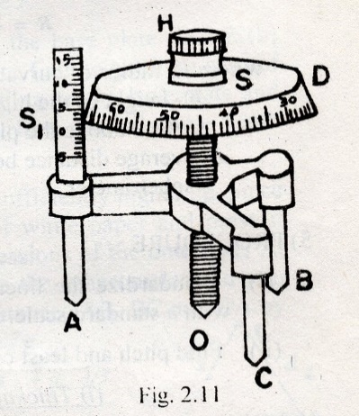
It consists of a micrometer screw fixed to a metallic frame provided with 3 legs A, B and C arranged at the corners of an equilateral triangle (fig. 2.11). A circular disc (D) is attached to the screw in the top. The bottom of the screw ends in a pointed leg O which forms the central leg or movable leg. The circumference of the circular disc is divided into 100 divisions. This scale is circular scale S. for rotation of the circular scale a milled head H is provided on the top of the disc. A linear vertical scale S₁ fixed on one of the legs gives the vertical displacement of the circular scale. The principle of working of spherometer is same as that of the screw gauge.
- THEORY:
Thickness of the plate = pitch scale reading (PSR.) + Circular scale reading (CSR).
Thickness = pitch x N + LC x (I~F).
Pitch and least count (LC): Pitch and LC are determined in the same manner as are done in case of screw gauge.
To determine pitch, give 10 complete rotations to circular scale and note the shift in distance of circular scale over the linear vertical scale. Then, divide this distance by 10 which gives the value of pitch. The pitch divided by the number of total circular scale division gives least count (LC) of the spherometer. The spherometers commonly used are of pitch 0.05 cm or 0.1 cm. accordingly, the L.C are 0.0005 cm or 0.001 cm respectively.
The radius of curvature (R) of a curved surface is the radius of the sphere of which the curved surface is a part. The working formula used for finding R is given by
R = $\frac{d^{2}}{6h}$ + $\frac{h}{2}$
Where R- radius of curvature of a curved surface
h- Height of the highest point of a convex curved surface above the plane of the tips of fixed legs fig.2.12
d- Average distance between any two fixed legs of the spherometer.
- PROCEDURE:
- Standardize the linear vertical scale S₁ by comparing with a standard scale.
- Find pitch and least count of given spherometer
(i)Thickness of the thin plate
(iii) Place the spherometer on the base plate, after raising central leg sufficiently higher up.
- Introduce the given plate (test plate) below the central O and lower it till it touches the test plate. Note the initial circular scale coincidence ICSC (I.
- Remove the test plate after tilting the spherometer a little the gap between the base plate and the tip of central gives the thickness of the test plate.
- Turn the milled head to close the gap and note the number of complete rotation (N).
- Note the final circular scale coincidence FCSC (F) when the gap is closed i.e. when the tip of the central leg just touches the base plate. Calculate the difference (I~F) as done in screw gauge. As the measurements are made by noting difference (I~F), zero error need not be considered.
- Find out PSR = pitch x N and CSR. = LC x (I~F). The sum of the two gives the thickness of the given plate.
- Repeat procedures (iii) to (viii) for 10 times and enter in tabular form as under.
(ii)Radius of curvature R of a curved surface
- To find h, place the spherometer first on the convex surface and lower the center at leg till it touches the highest point fig. 2.12(a) and note I.
- Then place the spherometer on the base plate fig.2.12 (b) and note N and F. Use table IV to find height h. In case of concave surface take initial reading on the base plate and final reading on the concave surface similarly note depth (h₂) fig.2.12(c).
- To find d, raise the central leg sufficiently higher up, place the spherometer on a sheet of white paper and press it gently so as obtain the impressions of the outer legs A, B and C on the paper. Remove the spherometre and join the point’s fig.2.13. Measure distances AB, BC and CA by meter scale and take their mean i.e. C
D = $\frac{AB+BC+CA}{3}$ = (d₁ +d₂ + d₃)/3
d₃ d₂
A B
d₁
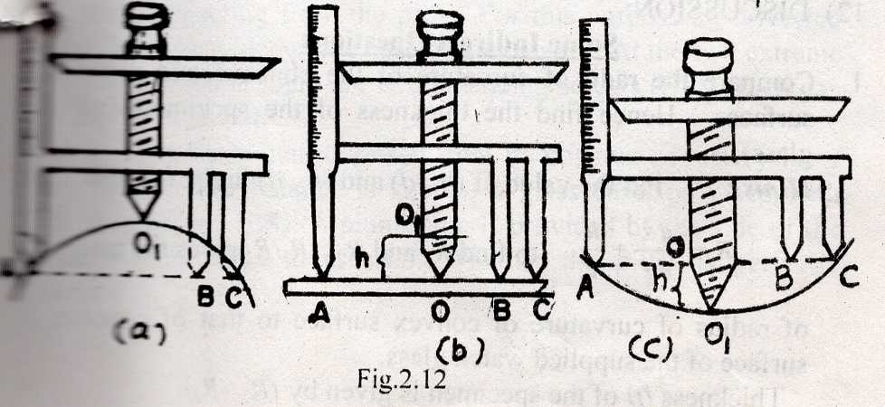
- PRECAUTIONS:
- The reading should be taken by moving the screw only in one direction to avoid back-lash error.
- Move the screw by holding the head arrangement.
- Three legs of the spherometer should touch the plane glass plate properly.
- OBSERVATION: Tabulation-IV
No. of obs. | Pitch (P) cms. | LC  cms | ICSC  (I) | N | FCSC  (F) | (I~F) | PSR = Pitch x N  cms | CSR = (I~F) x LC  cm | Total height or thickness = (PSR + CSR) cm | Mean height or thickness  cm
1
2
3
4
5
6
7
- CALCULATION:

- RESULT:
The required thickness/ depression/ elongation is found to be………
Experiment 4 Acceleration due to Gravity (g) by simple Pendulum
- AIM:
To find the acceleration due to Gravity (g) by Simple Pendulum
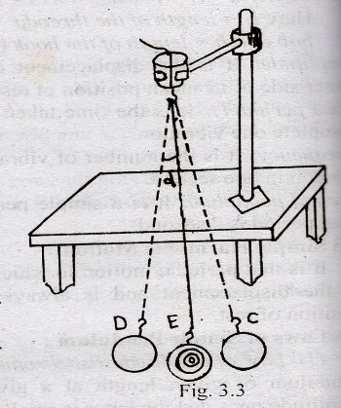
- APPARATUS:
- A brass bob with hook b) stop watch c) slide caliper d) split cork pieces thread e) meter scale f) stand
- DESCRIPTION:
In practice, a simple pendulum is a heavy material bob suspended by cotton thread from a rigid support. The distance of center of gravity of the bob from the point of suspension is called its effective length (I). It executes simple harmonic motion when drawn to one side and then released (fig.3.3). Its amplitude should be small (less than 4⁰).
- THEORY:
The time period (T) of oscillation is given by
T = 2$π√\frac{l}{g}$ or g = 4$π^{2}$ $\left[\frac{l}{T^{2}}\right]$
Where g-acceleration due to gravity
l-the effective length, l =l₁ + r + h
T-time period
L1 length of the thread
r- Radius of the bob
h- Length of the hook
The g measurement involves the determination of:
- Effective length l = l₁ + r + h. b) Time period T.
- PROCEDURE:
- Calculate the radius of the bob (r) with the help of slide caliper. Then calculate the sum of the diameter and length of the hook i.e. (2r + h) with the help of the slide caliper. Subtract mean value of r from the mean value of (2r + h) which gives (r + h). For this follow the standard procedure and tabulation for slide caliper (refer exp.2.1). Let the mean value of (r + h) = 2.4 cm (say).
- Take a cotton thread about 120 cm and tie one end of it to the hook of the bob. Make 6 to 7 ink marks at an interval of 10 cm on the other end of the thread. For convenience, put ink marks at a distance of 37.6 cm, 47.6 cm, 57.6cm, 67.6 cm, 77.6cm, 87.6 cm and 97.6 cm in order to get the lengths of the pendulum as 40 cm, 50 cm, 60 cm, 70 cm, 80 cm, 90 cm and 100 cm respectively.
- Place the other end of the thread in between two split cork pieces such that first ink mark will be the point of suspension and clamp it tightly on a stand. Place the stand on a table.
- Make a chalk mark on the edge of the table exactly in front of the thread. This will serve as mean position of rest for the thread. Make another two chalk marks on either side of the mean position of rest at a distance of 2 cms. This will limit the amplitude to 4⁰
- Draw the bob parallel to the edge of the table through a small distance and release. The pendulum will oscillate in a vertical plane within two extreme chalk marks. The bob will execute simple harmonic motion for some time. Leave first few oscillations.
- Start counting zero when the bob is at one end of the oscillation and start the stop watch simultaneously. Stop the stop watch at the end of 20th count.
- Note the time taken for 20 complete oscillations with the help of stop watch and divide this time by 20 to get the time period (T).
- Repeat the steps from (ii) to (vii) by suspending the pendulum from other ink marks of the thread and tabulate.
- Draw (l~T²) graph, plotting l values on the X-axis and T² on the Y-axis. This will be a straight line passing through origin (fig. 3.4).
- PRECAUTION:
- The amplitude of the swing should be small.
- Time period should be counted only after the bob has undergone a few oscillations.
- Thread should be long enough and upper end of the thread should be rigidly fixed.
- The pendulum should not make zig-zag oscillations but must oscillate parallel to the edge of the table.
- OBSERVATIONS: Tabulation I
No. of obs. | Length of the thread I₁ in cms | (r + h) in cms | Effective length l in cms l = l₁ + r + h | Time for 20 Oscillations |  |  | Time period T = t/20 in sec | T² in sec² | l / T² | Mean l/ T²
 |  |  |  | t₁ | t₂ | Mean T
1
2
3

- CALCULATION:
- Analytical Method
T = 2𝜋√$\frac{l}{g}$ or g = 4𝜋² $\left[\frac{l}{T^{2}}\right]$
Substituting the value of l/T² from the table I, the g can be calculated.
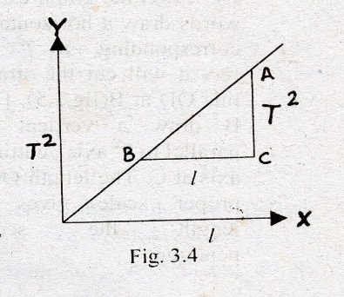
- Graphical Method
Plot a graph taking the length of the pendulum (l) along X-axis and T² along Y-axis. This will be a straight line passing through the origin (fig. 3.4). The slope of the line AC/BC gives the value of l/T². Putting the value of l/T² in the working formula g can be calculated.
G = 4𝜋² $\frac{l}{T^{2}}$ = 4𝜋² $\frac{AC}{BC}$
- RESULT: The value of acceleration due to gravity (g) is found out to be -------m/sec²
- STANDARD VALUE: g = 9.8lm/sec² or 980 cm/sec².
- ERROR:
Obs. Value (V_{obs}) = --m/s² stand value (V_{stan}) = 9.8m/s²
Percentage of error % E = $\left|\frac{\begin{matrix}V_{stan} & {-V}_{obs}\end{matrix}}{V_{stan}}\right|$ x 100 = --------%
Experiment 5 Determination of Refractive Index of the Material of a Prism
- AIM:
Determination of refractive index of the material of a prism
- APPARATUS:
- A prism b) board c) pins d) hairpins e) a piece of paper f) mathematical instrument box, etc.
- DESCRIPTION:
Prism is a portion of refracting material bounded by three planes. A cross-section of prism by a horizontal plane is triangular in form. Each of the three faces is called refracting faces. The line in which two refracting meet each other is called refracting edge.
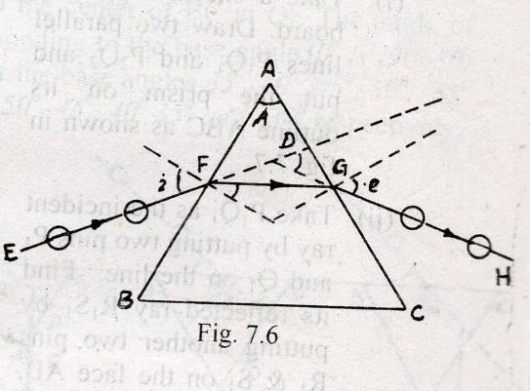
- THEORY:
A ray of light EF incident on one of the refracting faces gets refracted along the path FG through the prism and emerges along the path GH as shown in the figure 7.6. The angle between produced incident ray and the emergent ray is called angle of deviation d. for refraction through a prism,
I + e = A + D
Where I & e are the angle of incidence and angle of emergence respectively. A being the angle of prism and D is the angle of deviation.
Angle of deviation D depends upon the angle of incidence, deviation is minimum. It is denoted by D_{m} Refractive index of the material of the prism (μ) is related to the angle of prism A and the angle of minimum deviation D_{m} through the relation.

𝜇 = $\frac{\begin{matrix}sin & \frac{{A+D}_{m}}{2}\end{matrix}}{\sin{A/2}}$

Where μ – refractive index of the material of the prism
A – Angle of the prism
D_{m} – angle of minimum deviation
- PROCEDURE:
Measurement of refractive index of the material of the prism consists of two parts i.e. (1)
Determination of the angle of the prism A. (2) determination of angle of minimum deviation D_{m}.
- Determination of the angle of the prism
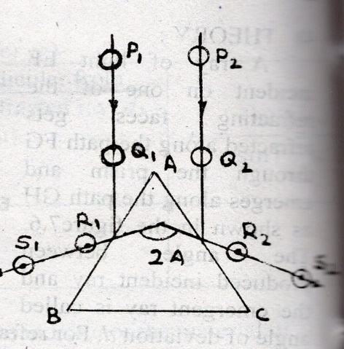
- Take a sheet of plane paper and fix it on a drawing board. Draw two parallel lines P₁Q₁ and P₂Q₂ and put the prism on its outline ABC as shown in fig. 7.7.
- Take P₁Q₁as the incident ray by putting two pins P₁ and Q₁ on the line. Find its reflected ray R₁S₁ by putting another two pins R₁ & S₁ on the face AB, such that the feet of the four pins appear to be along same line. Fig.7.7
- Repeat the same procedure taking P₂Q₂ as the incident ray to get reflected ray R₂S₂ on the face AC.
- Remove the pins and prism. Produce the reflected ray R₁ S₁ and R₂S₂ backward to meet at O. the angle ∠S₁OS₂ is equal to twice the angle of the prism i.e. 2A.
- Repeat the step (I) to (IV) to take a number of such observations and find mean 2A.
- Determination of angle of minimum Deviation by i-D Curve Method
- Take a sheet of plane paper and fix it on a drawing board with help of drawing pins. Draw a long straight line XY through the entire length of the paper fixed on the board. Mark points O₁, O₂ and O₃ …..Etc as shown in fig. 7.8.
- Draw straight line inclined to XY at angles of 30⁰, 35⁰,40⁰,45⁰,50⁰,55⁰ and 60⁰, at the points O₁, O₂, and O₃ …..Respectively. These inclined lines denote the incident rays and these angles are known as base angles, place the prism ABC with its BC surface coincident with the line XY with the center of BC at O₁. The angle of incidence corresponding to the base angle 30⁰ is (90-30) =60⁰ and that for the base angles 35⁰, 40⁰, 45⁰, 50⁰,55⁰ and 60⁰, are 55⁰, 50⁰,45⁰,40⁰,35⁰ and 30⁰ respectively.
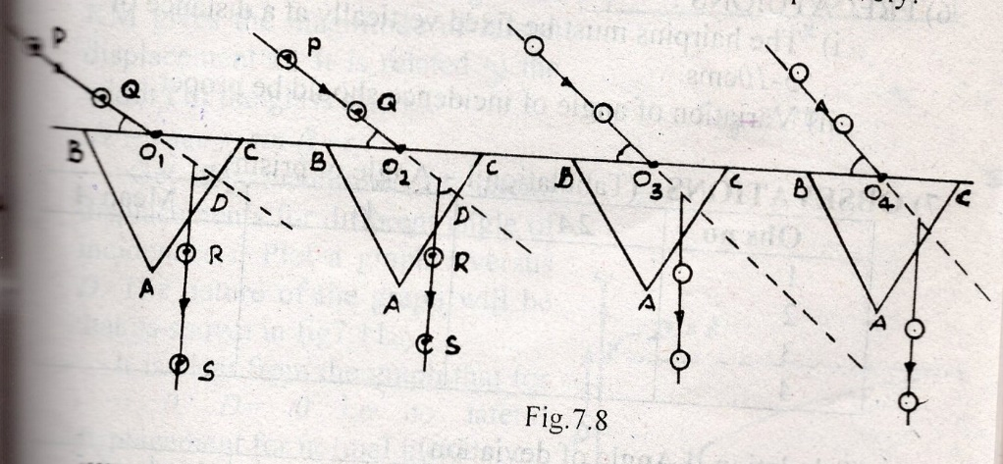
- Take PQ as the incident ray by putting two pins P and Q on the line. Find the refracted images of P & Q from other face AC. Fix another two pins R & S on the along same line, Remove the pins. Join RS to denote the emergent ray corresponding to the incident ray PQ.
- Produce the incident ray and emergent ray to get the angle of deviation D as shown in figure 7.8.
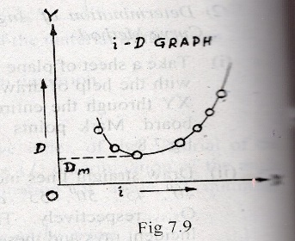
- Shift the prism surfaces to other points O₂, O₃ O₄... Etc. and repeat steps (iii) & (IV) to find the angle of deviations corresponding to the other angle of incidences.
- Plot a graph (i~D) taking angle of incidence I along x-axis and the angle of deviation D along the y-axis. The nature of the graph is shown in fig.7.9.
- Draw a horizontal line as a tangent to the lowest point of the curve. Intersection of this horizontal line on the y-axis gives the angle of minimum deviation D_{m} (fig.7.9).
- PRECAUTIONS:
- The hairpins must be fixed vertically at a distance of 5 – 10cms.
- Variation of angle of incidence should be proper.

- OBSEVATIONS: (Tabulation I – Angle of prism)

Obs no | 2A | A | Mean A
1
2
3
4

(Tabulation II Angle of deviation)
Figure No | Base angle | Angle of incidence i | Angle of deviation D
1
2
3
4

- CALCULATIONS:
Putting the mean value of A from table I and the angle of minimum deviation D_{m} from the graph, the refractive index of the material of the prism can be found out.

Experiment 6 Tracing the Lines of Force due to a Bar Magnet & Location of Neutral Point

- AIM:
To trace the lines of force due to a bar magnet and locate neutral point
- North pole of the bar magnet points north
- North pole of bar magnet points south
- APPARATUS:
- A bar magnet , b) compass needle c) drawing board fixing pines e) paper sheet f) two vertical stands with thread.
- DESCRIPTION :
- THEORY:
A line of force is a curve in magnetic field such that tangent drawn at any point of the curve gives the direction of resultant magnetic field at that point.
A neutral point is a point where the resultant magnetic field is zero. So a small needle placed at the neutral point will be at rest in any direction in which it is kept.
- PROCEDURE:
- Fix the paper sheet in the drawing board with the help of drawing pins. Place the magnetic needle at the center of
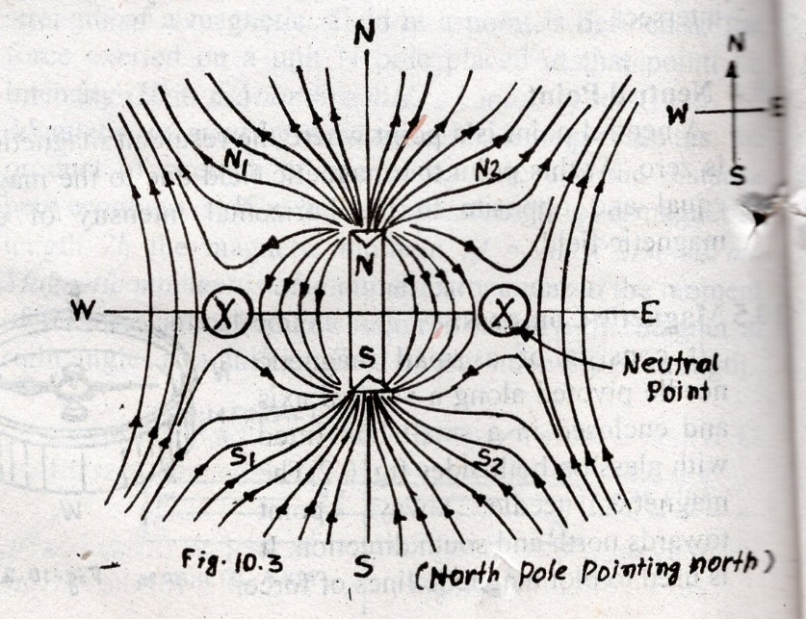
the paper sheet. This needle will set the magnetic meridian. Place two vertical wooden supports on either side of the board and attach two ends of a thread on the tips of these supports (fig.10.6). Adjust the positions of two wooden supports so that the thread is parallel to the magnetic needle. The thread is now along the magnetic meridian. Mark the boundary of the board with a piece of chalk.
- Place the bar magnet along the magnetic meridian with North Pole of the bar magnet pointing geographical north (fig 10.3) or North Pole pointing south (fig 10.4) as the case may be. Mark the boundary of the magnet with the lead pencil. Do not disturb the board and magnet.
- Place the compass needle near one end N of the magnet and mark its boundary. Put two pencil marks on the paper corresponding to the position of both ends of the needle. Move the needle to other position, so that one end of it coincides with the previous mark already plotted and put another mark at the other end. In this way shift the needle from one position to the next till the other pole of the magnet is reached. Join all the points by continuous curve. This curve is the line of force.
- Plot several such lines of force symmetrically on both sides of the magnet till whole field is marked out.
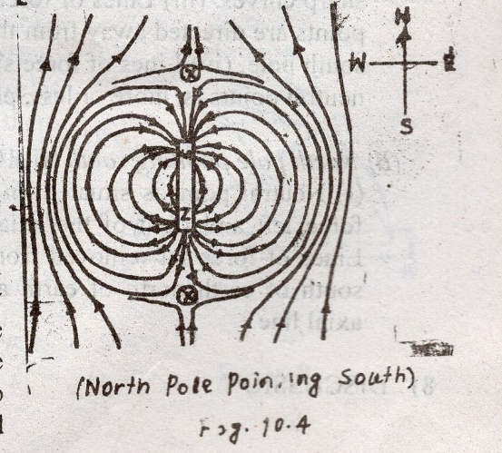
- Place the compass on the axial line (in fig.10.4) and on the equatorial line (in fig. 10.3) and move it away from the magnet slowly. Locate the neutral point by observing the points where the needle is found to move freely and likely to come rest in any arbitrary direction i.e. no magnetic influence is felt by magnetic needle. Fig 10.3 shows magnetic lines of force and neutral point for North Pole of the bar magnet pointing north and fig 10.4 that for North Pole pointing South.
- PRECAUTIONS:
- All the magnetic materials must be removed from the place of working.
- The board and the magnet should not be disturbed while plotting the lines of force.
- Use sharp pencil to mark the points and join the lines of force.
- Denote the directions of lines of forces by arrow heads.
- OBSERVATIONS:
Following observations are made from the plots of lines of forces.
- North Pole pointing north (fig 10.3).
- Neutral point is situated on the equatorial line (ii) Lines of force between magnetic axis and the neutral points are sharp curves. (iii) Lines of force above or below the neutral points are directed away from the North Pole or towards the South Pole. (iv)Lines of force situated on left or right of the neutral points is, more or less, parallel to the magnetic axis.
- North Pole pointing south (fig 10.4).
- A neutral point is situated on the axial line. (ii) Lines of force left and right of the axial line are sharp curves. (iii) Lines of force far removed from the axial line; move from south of earth north of earth and more or less parallel to axial line.
- DISCUSSION :

